**NaPDI Repository Experiment Report**

**In Vitro Enzyme Kinetics Experiment(s)**

**Please fill in all relevant fields to the experiment(s) performed. Submit a separate form for each unique set of experimental conditions.**

1. **General Information**

|  |  |
| --- | --- |
| **Title of experiment** |  |
| **Research organization** |  |
| **Test system (please see appendix I for options)** |  |

|  |  |  |  |  |  |
| --- | --- | --- | --- | --- | --- |
| **Experiment number and title** | **Object name (therapeutic class)** | **Object concentration (µM or µg/mL preferred)** | **Enzymes involved in metabolite pathway (provide all major)** | **Name of object metabolite(s) measured** | **Method for determination** |
| **1.** |  |  |  |  | parent disappearance  metabolite formation |
| **2.** |  |  |  |  | parent disappearance  metabolite formation |
| **3.** |  |  |  |  | parent disappearance  metabolite formation |

(Add more rows if needed)

|  |  |
| --- | --- |
| **Additional information (e.g. please describe if precipitant is an extract or fraction of a natural product, or if a cocktail of probe substrates was used, etc. )** |  |

**An example of data entered in the repository on the admin side:**

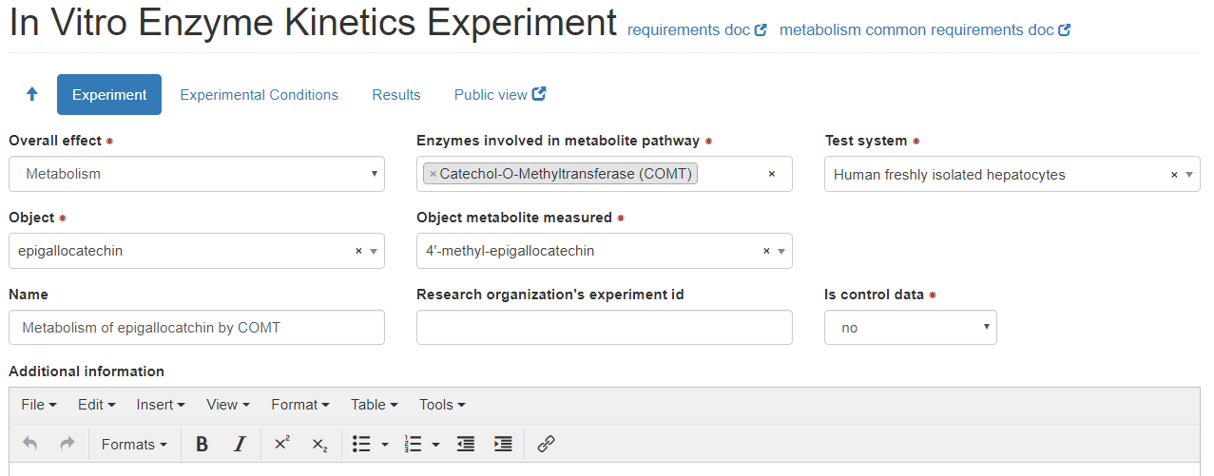

1. **Experimental Conditions**

|  |  |
| --- | --- |
| **Cell density** |  |
| **Protein concentration** |  |
| **Test system preparation**  **(check one if applicable)** | In-house preparation  Commercially available |
| **Test system lot number (manufacturer)** |  |
| **Incubation volume (µL units preferred)** |  |
| **Incubation time (min units preferred)** |  |
| **Co-factors (check all that apply)** | MgCl2  NAD  NADH  NADPH  NADPH regenerating system  P450 reductase |
| **Co -substrates (check all that apply)** | UDPGA  PAPS  GSH |
| **Protein linearity tested?** | Yes  No |
| **Time linearity tested?** | Yes  No |

**Additional information regarding experimental conditions:**

|  |  |
| --- | --- |
| **Additional Information** |  |
| **Control conditions** |  |

**An example of data entered in the repository on the admin side:**

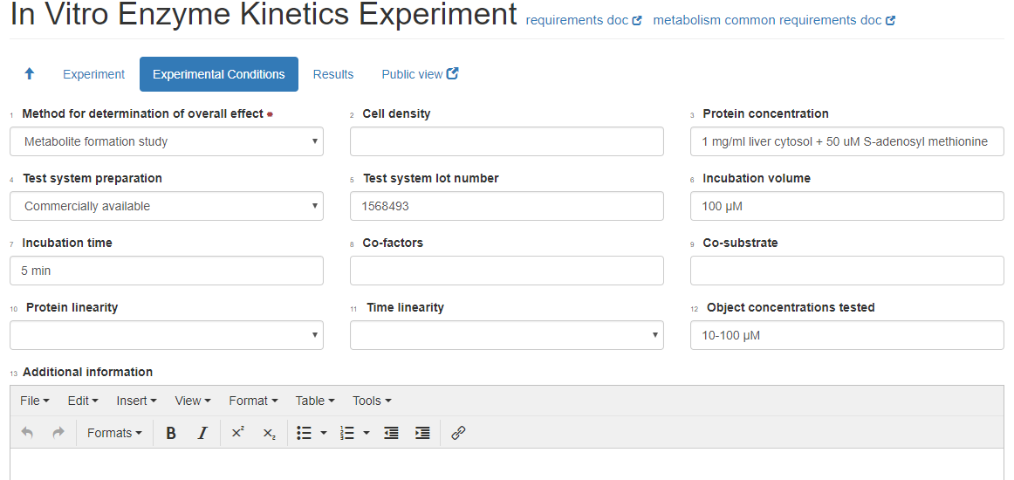

**3. Brief Summary of Results**

**For each experiment, please provide a brief summary of the results and conclusions**

|  |  |  |  |  |
| --- | --- | --- | --- | --- |
| **Experiment number and title** | **Kinetic Parameter:**  **value (provide units)** | **Value type(s)**  **(see Appendix II for list)** | **Number of experiments conducted** | **Experiment type** |
| 1. | Km:  Vmax:  CLint total:  CLint unbound:  Percent bound:  Method for protein binding determination:  Equilibrium dialysis  Ultrafiltration  Ultracentrifugation |  |  | Control  Test |
| 2. | Km:  Vmax:  CLint total:  CLint unbound:  Percent bound:  Method for protein binding determination:  Equilibrium dialysis  Ultrafiltration  Ultracentrifugation |  |  | Control  Test |
| 3. | Km:  Vmax:  CLint total:  CLint unbound:  Percent bound:  Method for protein binding determination:  Equilibrium dialysis  Ultrafiltration  Ultracentrifugation |  |  | Control  Test |

(Add more rows if needed)

|  |  |
| --- | --- |
| Additional Information |  |
| Conclusion |  |

**Attach relevant figures and tables of results when submitting this form.**

**Appendix I: Test Systems**

* **Cell system**
* Hepatocytes
* Human cryopreserved
* Human freshly isolated
* Transgenic animal
* Cell line
* HepG2 Cells
* HepaRG cells
* **Cell fraction**
* Human liver microsomes
* Pooled human liver microsomes
* Individual human liver microsomes
* Human intestinal microsomes
* Pooled human intestinal microsomes
* Individual human intestinal microsomes
* Cytosolic fraction
* Human liver
* Human intestine
* S9 fraction
* Human liver
* Human intestine
* **Recombinant expression system**
* Baculovirus-insect cells
* E.coli
* Yeast
* Not available

If “recombinant expression system” is used, make the selection for cytochrome b5 from the following:

**Cytochrome b5 (select one; required for recombinant expression system)**

* Yes
* Co-expressed
* Supplemented
* No
* Not available

**Appendix II: List of value types**

* Mean
* Mean ± SD
* Mean ± SEM
* Mean (range)
* Mean (CV%)
* Mean (CI)
* Median
* Median (CV%)
* Median (range)
* Median (CI)